Screen print of part 1 and 2 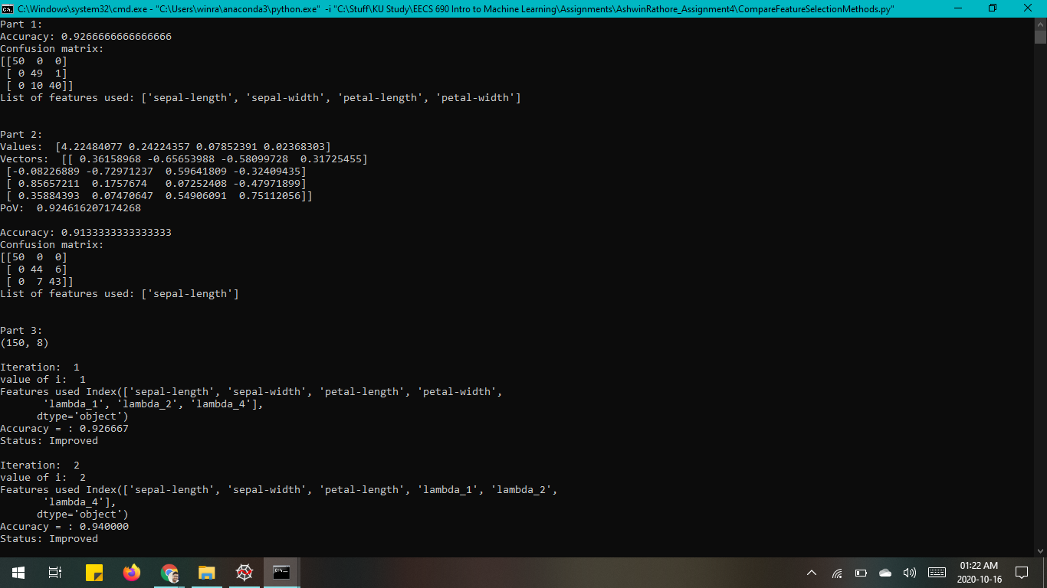

Screen print of part 3 with 100 iterations

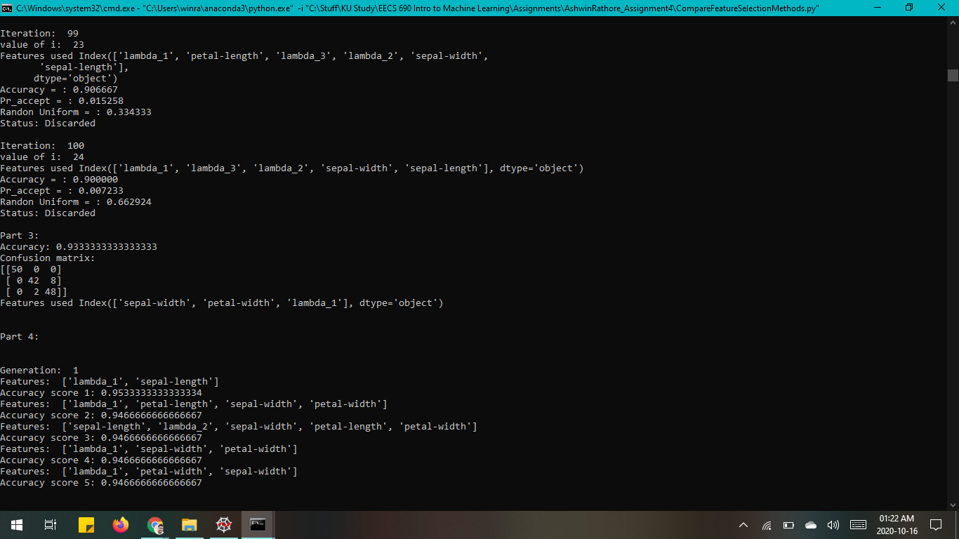

Screen print of part 4 with 100 iterations